Introduction
- Taxation is an essential part of financial planning, yet many individuals find it difficult to
understand how taxes are calculated and what factors influence their tax liability.

- Frequent changes in tax rules and the complexity of manual calculations often create
confusion, leading to inaccurate results and poor financial decisions.

- TaxPal is developed as a simple, user-friendly tax estimation system that helps users calculate
taxes quickly and accurately
.
- Users can input their income, deductions, and other financial details, and the system
automatically generates tax summaries based on predefined rules.

- The platform uses modern web technologies, ensuring smooth performance and an intuitive interface.

- The project provides a reliable tool for understanding taxable income and planning finances effectively.

- This documentation explains the purpose, scope, design, architecture, implementation, and testing of the TaxPal system in a clear and structured manner.

Problem Statement:
- Calculating taxes is often difficult and time-consuming, especially for people with limited financial or taxation knowledge.

- Traditional tax methods involve complex regulations, tax charts, manual calculations, and understanding exemptions and deductions, increasing the risk of errors.

- Users lack a single platform to track earnings, expenses, and financial activities throughout the year.

- Difficulty in maintaining records makes calculating tax liability during filing periods stressful, delayed, and prone to mistakes.

- Existing tax tools are often complex, expensive, or hard to use, especially for students, independent contractors, or beginners with basic financial literacy.

- There is a need for a simple, reliable, and automated system to help users estimate taxes without specialized knowledge.
- TaxPal aims to provide a user-friendly online platform that automates the tax estimation process, reduces errors, minimizes manual effort, and gives a clear understanding of financial obligations.
Objectives:
The main objective of the TaxPal project is to design and develop a user-friendly, automated,
and reliable tax estimation system that simplifies the financial planning process for users. The
system aims to reduce the complexity associated with manual tax calculations and provide a
clear understanding of tax liabilities. The project is focused on delivering accuracy, ease of use,
security, and a modern digital experience.
- To develop an automated tax calculation system that computes tax liabilities based on user-provided income, deductions, and financial details.

- To simplify the tax estimation process by eliminating the need for manual calculations and reducing the risk of errors.

- To create a secure user authentication system that ensures privacy, data protection, and restricted access to user accounts.

- To provide a clean and intuitive user interface (UI) that is easy to navigate for beginners as well as experienced users.

- To offer financial record management features that allow users to track income, expenses, and deductions throughout the year.

- To generate summary reports and visual insights that help users understand their tax breakdown and overall financial health.
- To integrate modern technologies such as React.js, Node.js, Express.js, and MongoDB for scalability and performance.

- To design a modular and scalable architecture that can support future enhancements like GST calculations, multi-user roles, and more.

- To apply best practices of software engineering, including documentation, testing, and version control.

Scope of the Project:
The scope of the TaxPal project covers the complete workflow of tax estimation, financial
tracking, and summary generation. This project focuses on building a user-centric platform that
automates tax calculations while maintaining simplicity, accuracy, and security. The system is
designed for individuals, students, freelancers, and professionals who require an easy-to-use
solution for understanding and managing their taxes.
Functional Scope
- User Authentication System
  - Secure registration and login using encrypted credentials.
  - Session management using JWT tokens.
- Dashboard Module
  - Displays user’s income overview, tax summary, and graphical insights.
  - Quick access to important features and recent activity.
- Tax Estimation Module
  - Inputs such as total income, deductions, and exemptions.
  - Calculation of taxable income based on predefined rules.
  - Final tax liability displayed clearly for user understanding.
- Transaction Management
  - Users can add income and expense records.
  - Records categorized for better financial planning.
  - Ability to view, update, or delete entries.
- Reports and Summary Generation
  - Monthly and yearly tax summaries.
  - Downloadable or viewable breakdowns.
  - Visual representation using charts.
- Profile and Settings
  - Users can manage profile details.
  - Secure access and logout functionality.

Non-Functional Scope
- Security
  - Password hashing and secure authentication.
  - Protection against unauthorized access.
- Performance
  - Fast response times with optimized backend APIs.
  - Smooth UI rendering with React.js.
- Scalability
  - Modular architecture for adding more features.
  - Database design supports growing user base.
- Usability
  - Simple, intuitive design suitable for all age groups.
  - Mobile-responsive interface for portability.
- Maintainability
  - Code structured with reusable components.
  - Clear documentation for future updates.

Software Requirements:
- VS Code / IntelliJ
- Node.js
- Express.js
- MongoDB
- React.js
- Figma (for UI design)

Frontend: React.js, HTML, CSS, JavaScript, Tailwind CSS

Backend: Node.js, Express.js

Database: MongoDB Atlas

Version Control: Git, GitHub

Design: Figma

Installation Steps:

Step 1: Install Node.js

Download and install Node.js from the official website.
Node also installs npm, which is used to install dependencies.

Step 2: Install MongoDB
- Download MongoDB Community Server from the MongoDB website.
- Install and make sure the MongoDB service is running on your system.
- Default connection URL:
- mongodb: //localhost:3000

Step 3: Clone or Download the Project

Open terminal/command prompt and run:

https://github.com/springboardmentor0316/Batch4_Taxpal_Team_4.git

Or you can manually download the project folder.

Backend Setup
- Navigate to the backend folder:
- cd backend
- Install backend dependencies:
- npm install
- Create a new .env file with the following configuration:
- PORT=5000
- MONGO_URI=mongodb://localhost:27017/taxpal
- JWT_SECRET=your_secret_key
- Start the backend server:
- npm start

Server will run on:

http://localhost:5000

Frontend Setup
- Navigate to the frontend folder:
- cd frontend
- Install frontend dependencies:
- npm install
- Start the React development server:
- npm start

Frontend will run on:

http://localhost:3000

14.4 Running the Application

Once both servers are running:
- Frontend (React) → http://localhost:3000
- Backend (Node/Express) → http://localhost:5000
- Both communicate through API endpoints.

You should now be able to:
✔ Sign up / login
✔ Add income and expenses
✔ Get live tax estimation
✔ View dashboard and charts

14.5 Database Setup

If you want to initialize default categories or test data:
- Create a MongoDB database named:
- taxpal
- Use a tool like MongoDB Compass to insert sample collections such as:
  - users
  - transactions
  - categories
  - tax_summaries

Folder Structure
TaxPal/
├── backend/
│ ├── src/
│ │ ├── main/
│ │ │ ├── java/
│ │ │ │ └── com/taxpal/
│ │ │ │ ├── controller/
│ │ │ │ ├── service/
│ │ │ │ ├── repository/
│ │ │ │ ├── model/
│ │ │ │ └── config/
│ │ │ ├── resources/
│ │ │ │ ├── application.properties
│ │ │ │ └── static/
│ │ │ └── webapp/
│ │ └── test/
│ ├── pom.xml
│ └── README.md
│

├── frontend/
│ ├── public/
│ ├── src/
│ │ ├── components/
│ │ ├── pages/
│ │ ├── assets/
│ │ └── App.js
│ ├── package.json
├── .gitignore
└── README.md

Sign Page:
The Sign-In Page serves as the primary authentication interface for users accessing the TaxPal platform. It ensures that only authorized individuals—such as taxpayers, administrators, or financial managers—can access the system’s secure dashboard and tax management features.
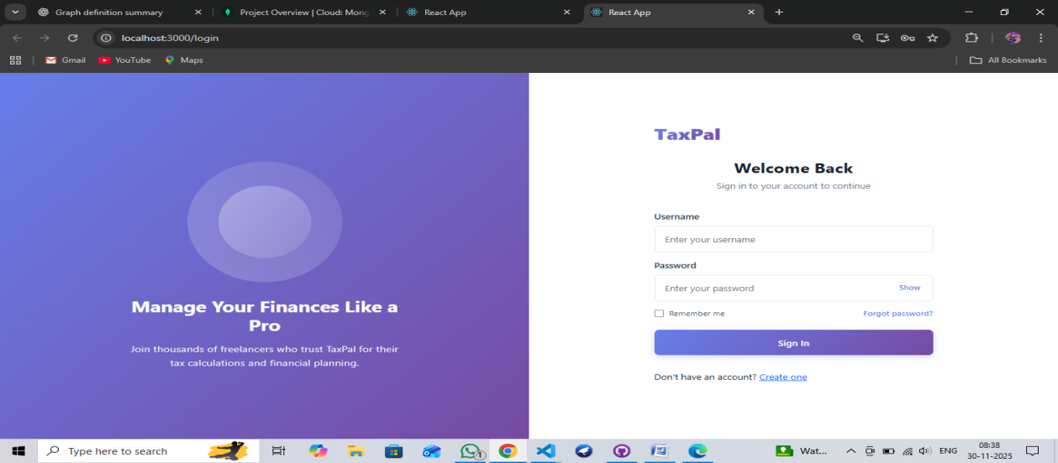
Email/Username Input Field
Allows users to enter their registered email address or username. Input validation ensures that only correctly formatted entries are accepted.
Password Input Field
Secure password input with masked characters to protect user credentials. The system restricts weak passwords and validates login attempts securely.
Login Button
Authenticates user credentials and redirects valid users to the Dashboard. Errors such as “Invalid password” or “Account not found” are shown clearly.
Forgot Password Link
Helps users reset their password through a secure, email-based recovery process.
Create Account Option
Redirects new users to the registration page where they can create a new TaxPal account.
Sign-Up Page Description
The Sign-Up Page is a critical component of the TaxPal system that enables new users to create their accounts and gain access to the platform’s tax management features. It is designed to provide a smooth and user-friendly registration experience, ensuring that users can securely submit their credentials and begin using the system immediately.
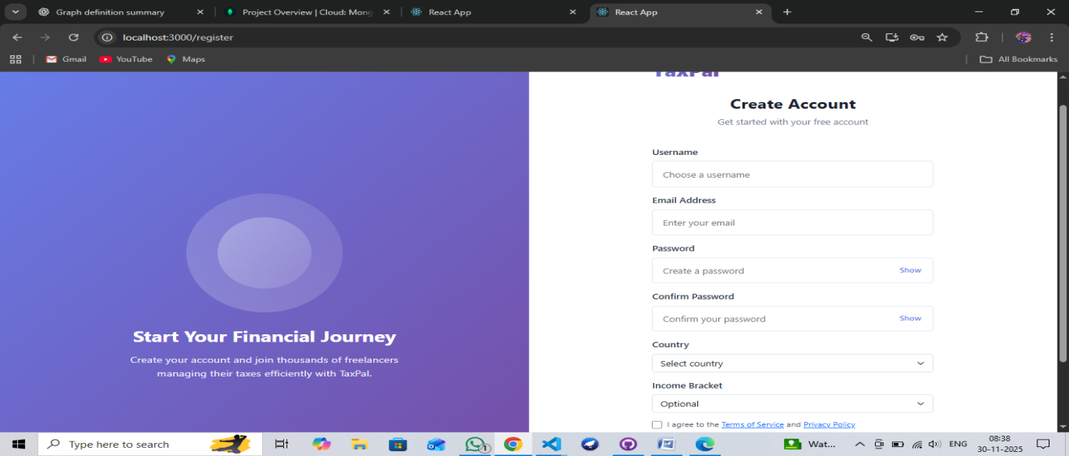
Key Features
- Simple Registration Form: Easy-to-use layout for quick account creation.
- Essential Input Fields: Name, Email, Mobile, Password, Confirm Password.
- Validation Checks: Ensures correct email format and matching passwords.
- Secure Data Handling: Encrypts passwords and protects user information.
- Error Messages: Shows clear alerts for invalid or missing inputs.
- Create Account Button: Submits the form and registers the user.
- Navigation Link: Redirects existing users to the Sign-In page.
Forget Password page
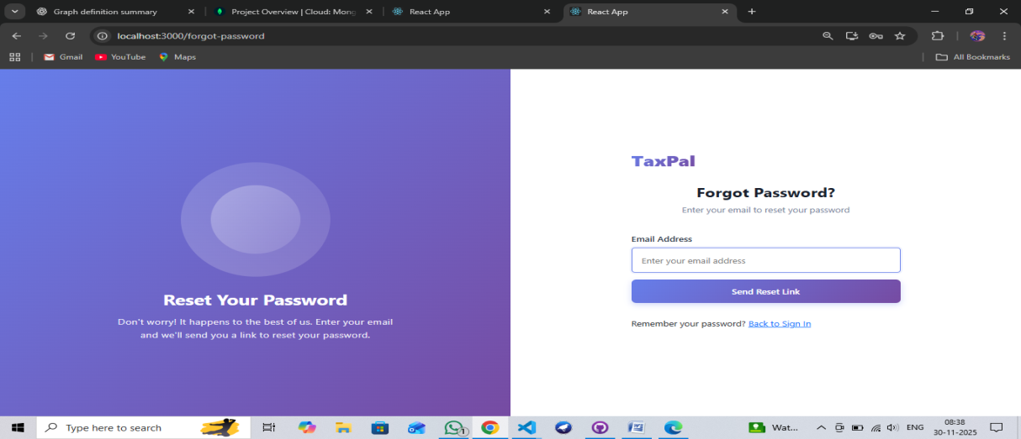
Key Features :
- Email Input Field: Allows users to enter their registered email for password recovery.
- Reset Link/OTP Sending: Sends a secure reset link or OTP to the user’s email.
- Clear Error Messages: Alerts users if the email is invalid or not registered.
- Secure Verification: Ensures only authorized users can request password resets.
- Time-Limited Links: Reset links or OTP codes expire for security.
- Easy Navigation: Includes a link to return to the Sign-In page.
- Simple Interface: Clean and user-friendly layout for quick recovery.
- Server-Side Validation: Prevents misuse or unauthorized password reset attempts.
Dashboard Page
The Dashboard Page is the central interface of the TaxPal system where users can view and manage all their tax-related activities. It provides a clear overview of important information such as tax records, payments, pending tasks, notifications, and user profile details. Designed with simplicity and usability in mind, the dashboard helps users quickly access key functions and navigate the system efficiently.
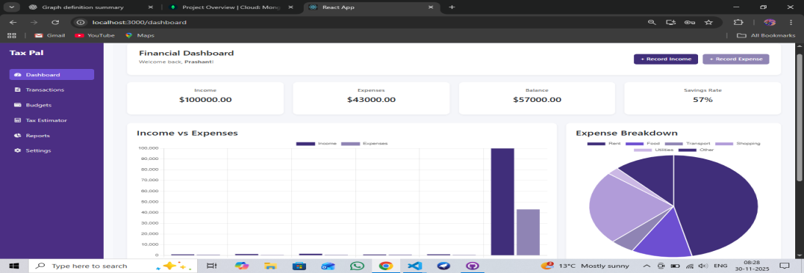

Dashboard Key Features
- User Overview: Displays user name and account info.
- Summary Cards: Quick stats like total tax, pending dues, and recent payments.
- Navigation Menu: Easy access to Tax Filing, Payments, History, Profile, and Settings.
- Recent Activities: Shows latest tasks, filings, and notifications.
- Alerts & Notifications: Reminds users of deadlines and important updates.
- Quick Action Buttons: Shortcuts for filing tax, making payments, and downloading reports.
- Charts & Visual Data: Graphical view of income, expenses, and payment trends.
- Responsive Layout: Works on desktop, tablet, and mobile devices.
- Secure Access: User-specific dashboard accessible only after login.
Transaction Page:
The Transaction Page in TaxPal allows users to manage, track, and review all income and expense records. It acts as a central hub for financial entries, helping users maintain accurate records for tax calculation and financial analysis. Users can add new transactions, update existing ones, and delete unnecessary records.
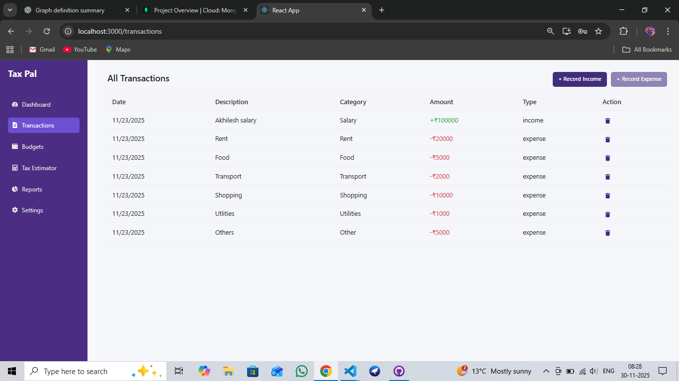

Key Features:
- Add Transaction: Users can enter new income or expense records with details like amount, date, and category.
- Update Transaction: Edit existing transactions to correct or update information.
- Delete Transaction: Remove transactions that are no longer needed.
- Filter & Search: Quickly find specific transactions by date, type, or category.
- Categorization: Organizes transactions into income and expense categories for clarity.
- Summary Display: Shows totals for income, expenses, and net balance.
- Export/Download: Allows users to download transaction history for record-keeping.
- Secure Access: Only authenticated users can view or modify transactions.
Tax Estimator Page:
The Tax Estimator Page in TaxPal allows users to calculate their estimated tax liability based on their income, deductions, and applicable tax rules. It provides a user-friendly interface for quick and accurate tax estimation, helping users plan their finances effectively. The page supports multiple input fields and generates results instantly without manual calculations.
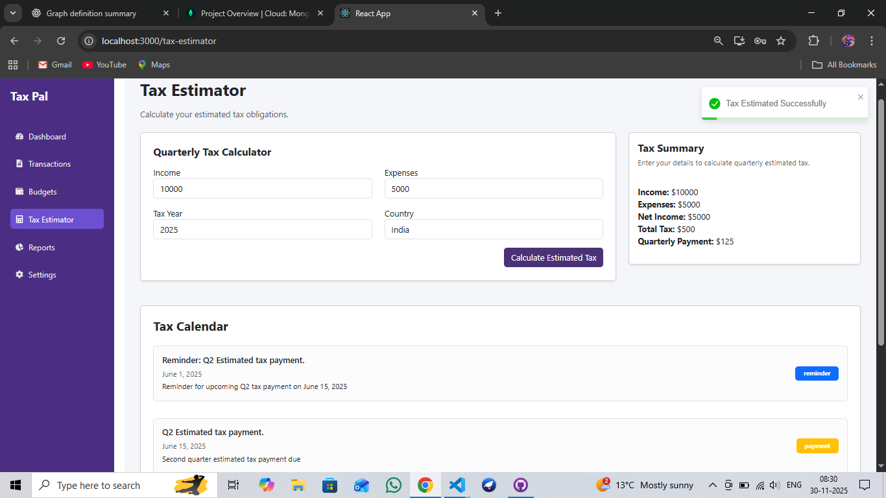

Key Features:
- Income Input: Users can enter salary, business income, or other sources of income.
- Deductions Entry: Allows input of eligible deductions like investments, insurance, and exemptions.
- Automatic Tax Calculation: Computes estimated tax based on current tax slabs and rules.
- Result Display: Shows total taxable income, tax payable, and breakdown of calculations.
- Visual Representation: Graphs or charts to illustrate tax breakdown.
- Save Estimation: Users can save estimates for future reference.
- Responsive Design: Works on desktop, tablet, and mobile devices.
- Secure Access: Only authenticated users can access personal tax estimation.
- Quick Navigation: Links to Dashboard, Transaction Page, and Reports for further actions.
Budget Page Description:
The Budget Page in TaxPal helps users plan, track, and manage their monthly or yearly income and expenses. It allows users to set budget limits for different categories and monitor spending patterns. This page provides a clear overview of financial health, enabling better decision-making and efficient tax planning.
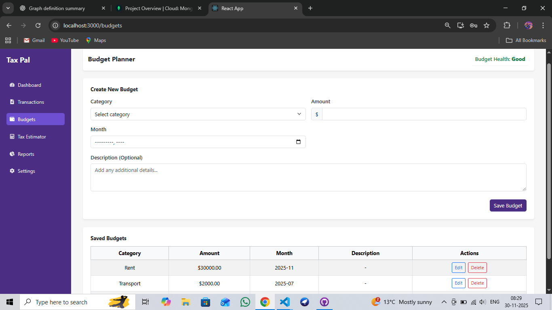

Key Features:
- Set Budget Limits: Users can define spending limits for categories like food, transport, bills, etc.
- Track Expenses: Automatically tracks expenses and compares them with set budgets.
- Income Overview: Displays total income and net balance after expenses.
- Visual Charts: Graphical representation of budget vs actual spending for easy analysis.
- Alerts & Notifications: Notifies users when spending exceeds budget limits.
- Edit & Update Budgets: Users can modify budgets anytime to reflect financial changes.
- Export Reports: Allows downloading budget summaries for record-keeping.
- Responsive Design: Accessible on desktops, tablets, and mobile devices.
- Secure Access: Only logged-in users can view and manage their budgets.
Reports Page Description
The Reports Page in TaxPal provides users with a comprehensive view of their financial and tax-related activities. It allows users to generate detailed summaries, track income and expenses, and review tax calculations over different periods. This page is designed to support better financial planning and analysis through visual and tabular representations.
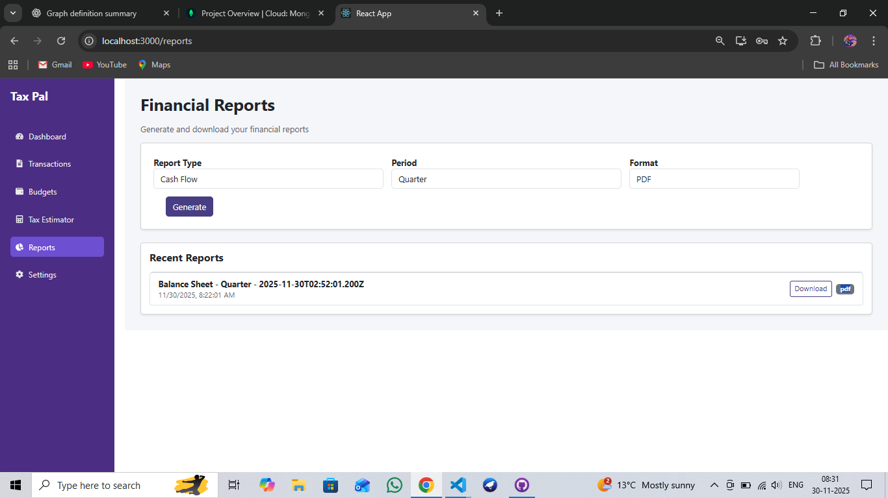

Key Features (Reports Page)
- Generate Reports: Users can create monthly, quarterly, or yearly reports.
- Income & Expense Summary: Displays total income, total expenses, and net savings.
- Tax Summary: Shows estimated or calculated tax liabilities based on user data.
- Graphical Charts: Visual representation of financial trends, including pie charts and bar graphs.
- Download & Export: Users can download reports as PDF or Excel files for record-keeping.
- Filter & Search: Allows filtering reports by date range, transaction type, or category.
- Secure Access: Only authenticated users can access their personal reports.
Settings Page:
The Settings Page in TaxPal allows users to manage and customize their account preferences, security settings, and notification options. It provides users with control over their personal data and how they interact with the system, ensuring a secure and personalized experience.

Key Features (Settings Page)
- Profile Management: Update personal information such as name, email, and contact details.
- Password Change: Allows users to securely update their account password.
- Notification Settings: Enable or disable alerts for tax deadlines, payments, and reminders.
- Privacy Settings: Control visibility of personal information and account security preferences.
- Account Deactivation: Option to temporarily deactivate or delete the account.
- Two-Factor Authentication (Optional): Enhance account security.
- Save & Apply Changes: Ensure that any changes made are updated immediately.
- Responsive Design: Fully accessible on desktop, tablet, and mobile devices.
- Secure Access: Only the logged-in user can modify their account settings.

Profile Section: Profile Section (Settings Page)
- View Personal Info: Shows user’s name, email, and contact details.
- Edit Details: Update name, email, and phone number with validation.
- Profile Picture: Option to upload or change picture.
- Secure Save: All changes are securely stored in the backend.
- Purpose: Keeps user information accurate and enhances personalization.

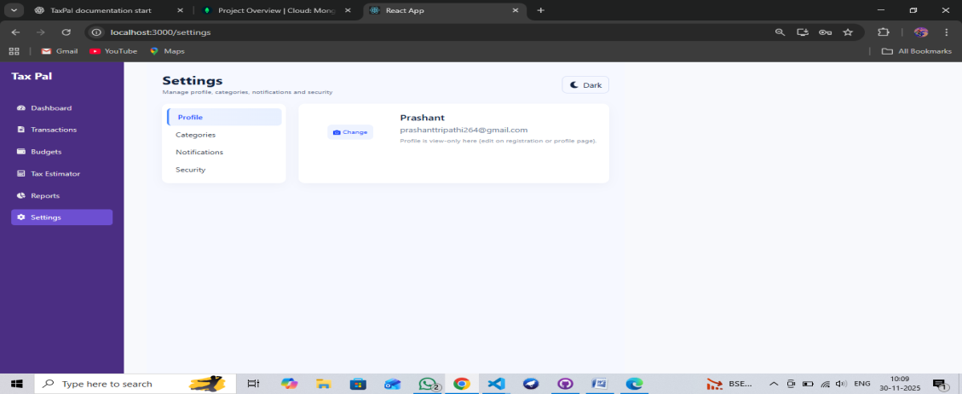
Category Section:
The Category Section allows users to organize their income and expense records into different categories. This helps in better tracking, reporting, and analysis of financial data. Users can add, edit, or remove categories according to their needs.
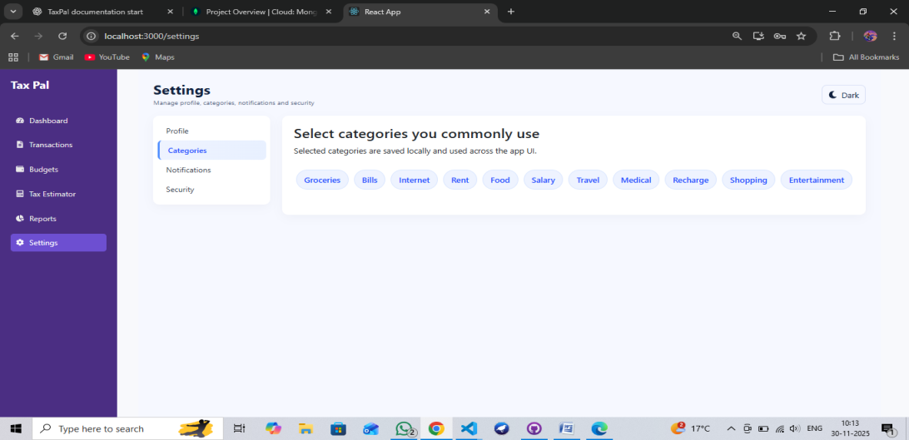

Key Features:
- Add Categories: Users can create new categories for income or expenses.
- Edit Categories: Modify existing category names for clarity.
- Delete Categories: Remove categories that are no longer needed.
- Categorization: Assign transactions to specific categories for better tracking.
- Filter by Category: View transactions based on selected categories.
- Reports Integration: Categories are used in charts and reports for financial analysis.

Notification Section :
The Notification Section allows users to manage alerts and reminders related to their account, tax deadlines, payments, and system updates. It helps users stay informed and ensures they do not miss important activities.

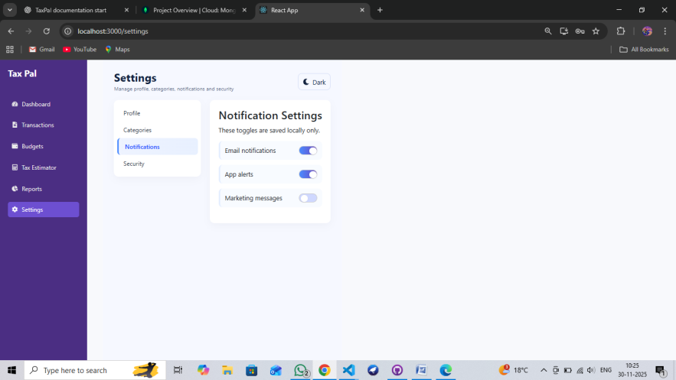
Key Feature:
- View Notifications: Displays all recent alerts and system messages.
- Enable/Disable Alerts: Users can turn on or off notifications for tax deadlines, payments, or reminders.
- Email/SMS Notifications: Option to receive notifications via email or SMS.
- Read/Unread Status: Marks notifications as read or unread for easy tracking.
- Clear Notifications: Delete old or unnecessary notifications.
- Secure Access: Only logged-in users can view their notifications.

Security Section:
The Security Section allows users to manage and enhance the protection of their TaxPal account. It provides options for password management, two-factor authentication, and other security settings to ensure that user data remains safe.
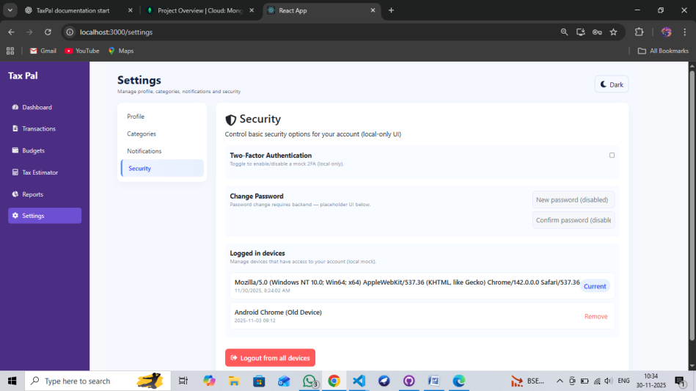

Key Features:
- Change Password: Users can securely update their account password.
- Two-Factor Authentication (2FA): Adds an extra layer of security via OTP or authenticator apps.
- Login Alerts: Notifies users of any unusual login activity.
- Session Management: View and manage active sessions; users can log out from other devices.
- Account Recovery: Options for password reset and account recovery.
- Secure Data Handling: All security changes are encrypted and validated on the server.
- Purpose: Protects sensitive information and prevents unauthorized access.

API Components
The API Components in TaxPal handle communication between the frontend and backend, enabling data transfer, user authentication, transaction management, and tax calculations. APIs are designed to be secure, modular, and scalable.
1. User Authentication APIs
- Login API: Validates user credentials and returns authentication tokens.
- Sign-Up API: Registers new users and stores encrypted credentials.
- Forgot Password API: Sends password reset links or OTPs to registered users.
- Change Password API: Allows users to securely update their passwords.

2. Profile Management APIs
- Get User Profile API: Retrieves user information for display in the dashboard and settings.
- Update Profile API: Allows users to edit personal information.
- Profile Picture API: Uploads or updates the user profile image.

3. Transaction APIs
- Add Transaction API: Adds a new income or expense entry.
- Update Transaction API: Updates an existing transaction.
- Delete Transaction API: Removes a transaction record.
- Get Transactions API: Retrieves all transactions for a user with filtering options.

4. Category Management APIs
- Add Category API: Create new categories for income/expense.
- Update Category API: Edit existing categories.
- Delete Category API: Remove unnecessary categories.
- Get Categories API: Fetch all categories assigned to a user.

5. Tax Estimation APIs
- Calculate Tax API: Computes tax based on income, deductions, and rules.
- Get Tax Summary API: Retrieves previous tax calculations for reference.

6. Budget APIs
- Set Budget API: Defines budget limits for categories.
- Get Budget API: Fetches current budgets and usage stats.
- Update/Delete Budget API: Modify or remove existing budgets.

7. Reports APIs
- Generate Reports API: Creates summaries for income, expenses, and tax over a selected period.
- Export Reports API: Allows downloading reports as PDF or Excel files.

8. Notification APIs
- Get Notifications API: Retrieves alerts and messages for the user.
- Mark as Read API: Marks notifications as read.
- Delete Notification API: Removes unwanted notifications.

9. Security APIs
- Enable/Disable 2FA API: Manages two-factor authentication settings.
- Login Alerts API: Sends notifications about suspicious login activity.
- Session Management API: Tracks and manages active sessions.

Error Handling
TaxPal implements robust error handling to ensure smooth user experience:
- Input Validation Errors: Users entering negative numbers or missing fields are prompted with descriptive messages.
- Server Errors: API failures return HTTP status codes like 400, 404, or 500 with clear messages.
- Database Errors: Connection or query failures are logged in the backend, while users see a friendly alert.
- Security Errors: Unauthorized access attempts redirect users to the login page and display “Access Denied”.
- UI Errors: Form submission failures or page rendering issues prompt helpful alerts without crashing the application.
Error handling follows best practices, including try-catch blocks, input sanitization, and logging for debugging and maintenance purposes.

9. Troubleshooting
To help users and developers address common issues:
- Login Issues: Verify username/password, check server connectivity, or reset the password.
- Tax Calculation Issues: Ensure all income and deduction fields are filled correctly and refresh the page if necessary.
- Transaction Saving Issues: Check network connection, confirm backend server and MongoDB are running.
- UI Display Issues: Clear browser cache, refresh the page, or try a different browser for compatibility.
- Server Errors: Review backend logs, restart the server, and ensure all services are running correctly.

10. Testing
- Unit Testing: Validates individual functions for tax calculations and API endpoints.
- Integration Testing: Ensures frontend-backend communication works correctly.
- UI/UX Testing: Verifies forms, charts, and dashboards are functional and user-friendly.
- Performance Testing: Assesses system response time and handling of large datasets.
- Version Control
- TaxPal uses Git as its primary version control system to ensure smooth and reliable management of the project codebase. Version control helps track changes, collaborate effectively, and maintain stable releases.

Key Version Control Practices Used in TaxPal
- Git Repository Management:
The entire project (frontend + backend) is maintained in a structured Git repository.
- Branching Strategy:
- Main/Master Branch → Contains stable, production-ready code.
- Dev Branch → Used for integrating new features and updates.
- Feature Branches → Separate branches for individual modules (e.g., feature-tax-estimator, feature-dashboard, etc.).
- Commit Standards:
- Each commit includes clear, descriptive messages.
- Bug fixes, updates, and new features are committed separately for clarity.
- Pull Requests / Code Reviews:
Before merging, changes are reviewed to ensure code quality and stability.
- Backup and Recovery:
Git ensures previous versions can be restored in case of errors or failures.
- Using Git ensures the team can maintain organized development, track issues, and avoid conflicts during collaborative work.

Updates and Maintenance
- TaxPal follows a structured update and maintenance strategy to ensure long-term reliability and scalability.
Regular System Updates
- Bug Fixes:
Issues reported by users or identified during testing are resolved through periodic patches.
- Feature Enhancements:
New features such as improved tax calculators, advanced reporting, or new dashboards are added through planned updates.
- UI/UX Improvements:
Enhancements to the user interface and experience based on feedback and usability testing.
- Performance Optimization:
Updates to improve speed, reduce load times, and handle large datasets efficiently.
Security Updates
- Regular updates to handle security vulnerabilities, authentication improvements, and data protection enhancements.
- Patch updates for backend technologies like Node.js, Express.js, and MongoDB.
Compatibility Updates
- Ensuring compatibility with the latest versions of:
- Browsers (Chrome, Firefox, Edge, Safari)
- Frameworks (React.js updates)
- Device types (desktop, tablet, mobile)
Version Release Cycle
- TaxPal follows a versioning format such as:
- v1.0.0 – Initial release
- v1.1.0 – Minor feature updates
- v1.2.0 – UI enhancements and bug fixes
- v2.0.0 – Major new modules or major system updates

